# Support multiple parameter defaults

# Functional Design

Author: Jon Totton

Date: December 1, 2013

Contents

Support multiple parameter defaults 1

Functional Design 1

Summary 1

User Interface 1

The “Select Sets” Dropdown Control 2

The “Manage Sets” Button 2

The Manage Sets Dialog 2

Localization 4

Known Bugs 5

## Summary

The user has the new capability to define and select named parameter sets. These sets can be either specific to the user or available to all users. Sufficient privilege is required to defined and manage sets available to all users. The functionality to save and / or load a default set will be as easy as it was before this change.

The new UI to enable these new capabilities will be exposed on the Toolbar exposed in the Parameter Pane. There will be one new dropdown and one new button. The dropdown will enable the user to select the named set and the button will launch a modal dialog that will enable the management (I.e., add, delete or modify) the named sets.

## User Interface

The new Toolbar on the parameter pane will look like this:

Machine generated alternative text: 

The first button will have tooltip “Manage Sets” and the dropdown will have a tooltip “Select Set”.

### The “Select Sets” Dropdown Control

When the user selects the new dropdown control, a list will be presented that shows both per user and all user named parameter sets (a.k.a., NPS). The NPS will be sorted alphabetically. When the user selects a set, the parameters are made current, the report is refreshed and the parameter pane is closed.

### The “Manage Sets” Button

When the user presses the Manage Sets button the parameters are validated. If any validation errors exist, the errors will be presented and the dialog will not be opened. The Manage Sets dialog may only be opened when valid parameters are entered. This is important because when the user presses the “Apply” button in the dialog, all named parameter sets are saved to the database. All saved parameter sets must be valid. This is consistent with the processing that happens with the “Save Parameters” button.

### The Manage Sets Dialog

#### Figure 1 - A User with “Update Parameters” permission:

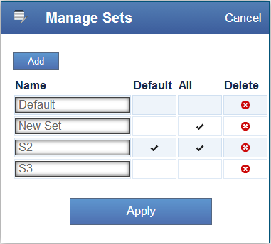

#### Figure 2 - A User without “Update Parameters” permission:

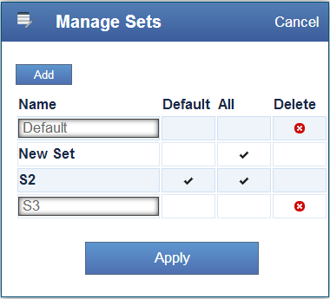

In Figure 2 above, the un-privileged user cannot: edit the name of, check or un-check the “All Users” check box or see the delete control for any “All Users” set. They can however make an “All Users” set their own personal default set. Default sets are defined on a per user basis.

The Manage Sets Dialog (a.k.a. MSD) will enable the user to add, delete and modified the NPS. The MPS will be ordered by set name. Set names do NOT have to be unique. Internally sets are identified by id not name. There must be at least one set and on default set.

#### Controls

Cancel



When the cancel button is selected, the MSD is closed and none of the changes made since the dialog was opened are saved.

Add



When the add button is selected, a new named set is created and the UI is updated accordingly. The new set will have the parameters that were defined when the MSD was launched. The Set name will default to “New Set”. This value is localized.

Apply



When the user selects Apply, all NPS are saved to the database. If the user has sufficient permission, both the per user sets and well as the all users sets are saved.

Delete



The delete control will delete the Named Parameter Set that is on the same row as the delete control. If the set is an “All Users” set only privileged users will see this control.

All Checkbox



If the user has sufficient privilege, the All Checkbox will be enabled. When the privileged user selects the check box it will toggle on / off. Any set that has the All Checkbox checked will be available to all users.

Default Checkbox



The default checkbox is used to indicate which set will be loaded when the report is loaded. There can only be one default set.

#### Permissions

In order for a user to be able to manage the “All Users” NPS, they must have the Report Services permission “Update Parameters”.

## Database

This feature required schema changes to the database. The database schema changes are automatically updated when a user upgrades from a previous version.

## Localization

All localization strings are defined in the section “manageParamSets” in the localization files. The English version looks like this:

"manageParamSets":{

"manageSets": "Manage Sets",

"cancel": "Cancel",

"add": "Add",

"addNewSet": "Add New Set",

"name": "Name",

"defaultHeader": "Default",

"allUsers": "All",

"deleteHeader": "Delete",

"apply": "Apply",

"newSet": "New Set"

}

## Known Bugs

The following are the currently the only know defects:

[Bug-700 “Need localizations for the new Named Parameter Sets feature”](https://forerunnersw.atlassian.net/browse/REPORTING-700)

[Bug-699 “SoapException thrown when calling RSNative.GetPermissions(path) in RSManagementProxy”](https://forerunnersw.atlassian.net/browse/REPORTING-699)